1. Open start.spring.io

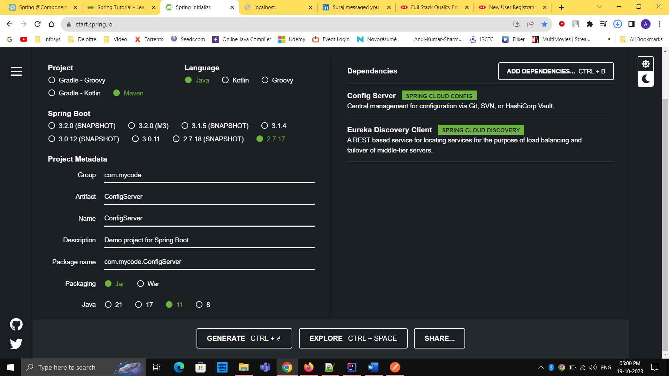

1. Open main application.java file

Add @EnableConfigServer

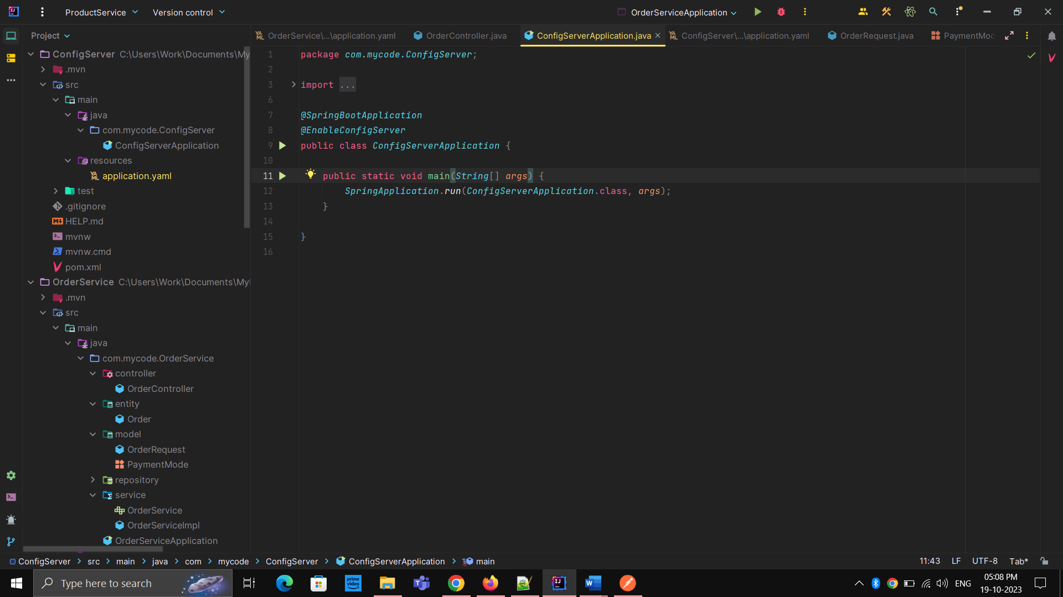

1. Open github and create a new repository

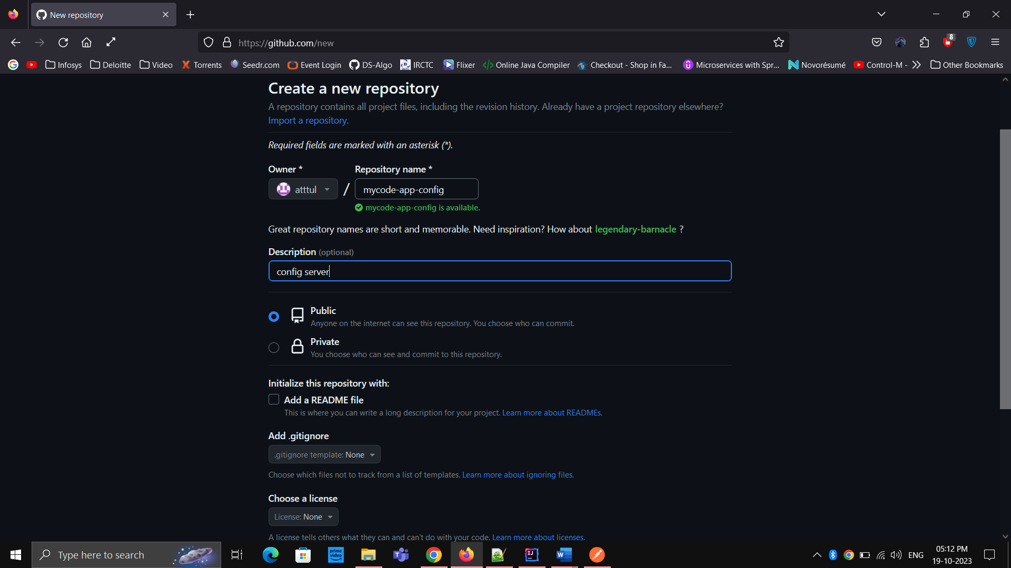

1. Copy this url

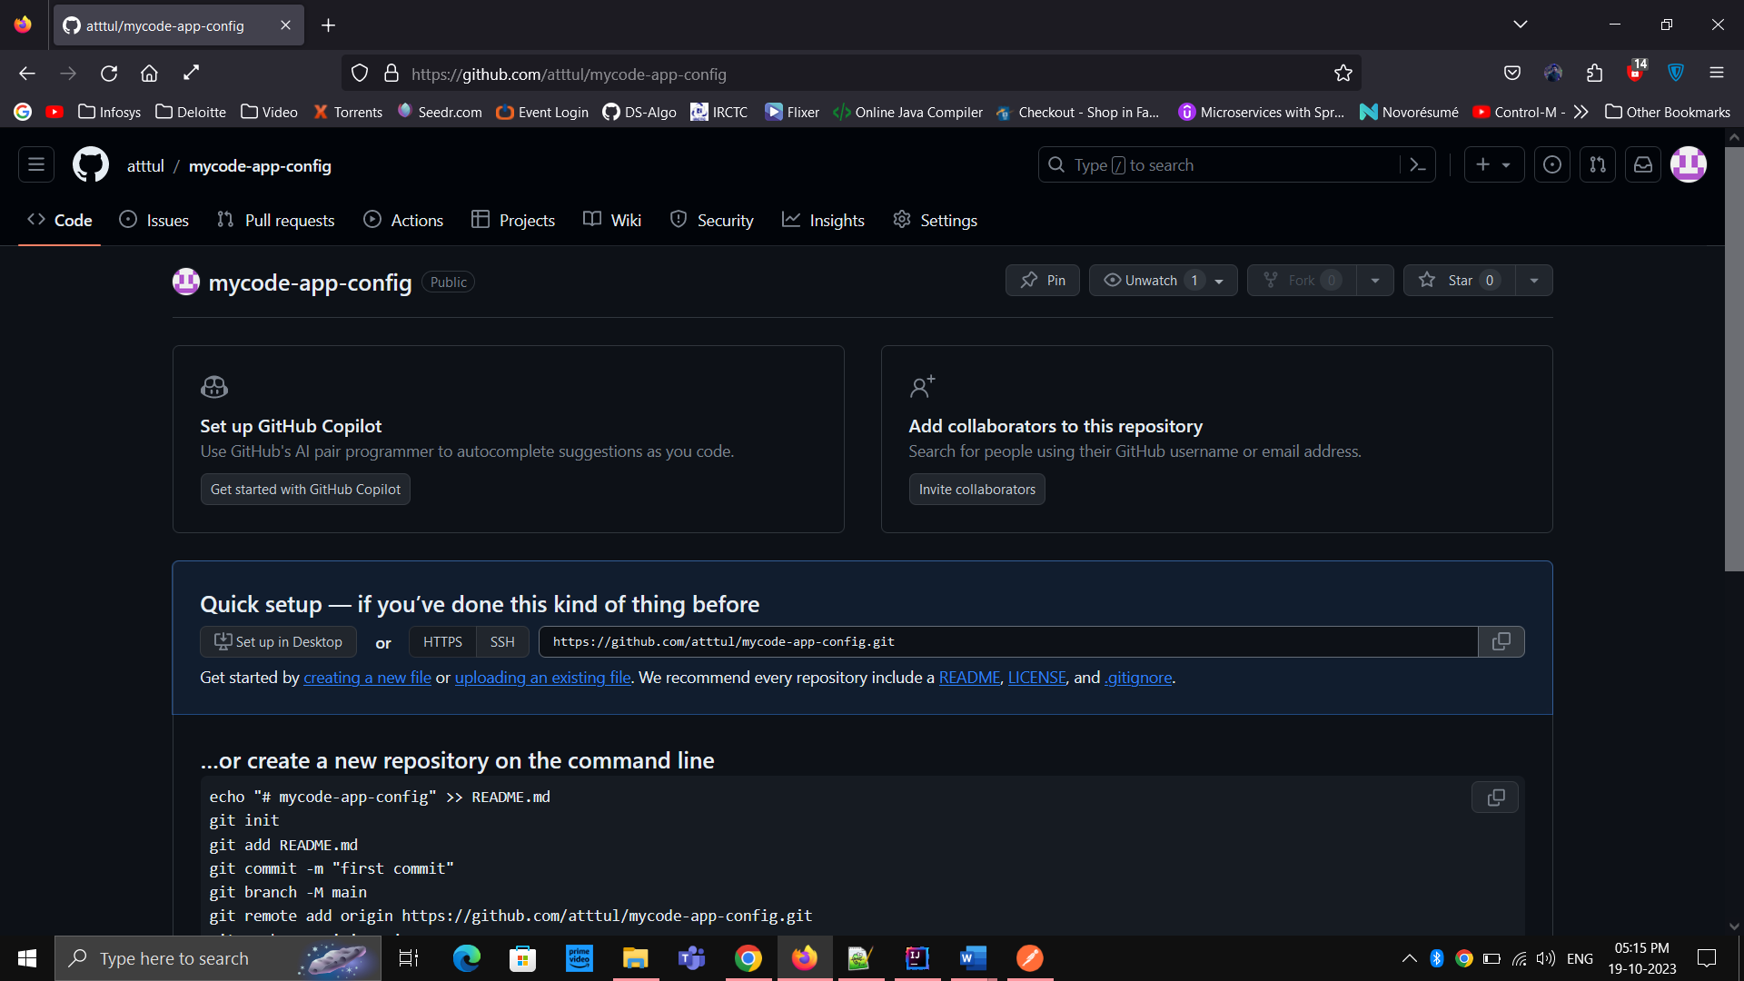

1. Open application.yaml

server:  
 port: 9296  
  
spring:  
 application:  
 name: CONFIG_SERVER  
  
 cloud:  
 config:  
 server:  
 git:  
 uri: https://github.com/atttul/mycode-app-config.git  
 clone-on-start: true

1. Create new file on GITHUB repository

And paste the common configurations in that file and then CO commit changes there.

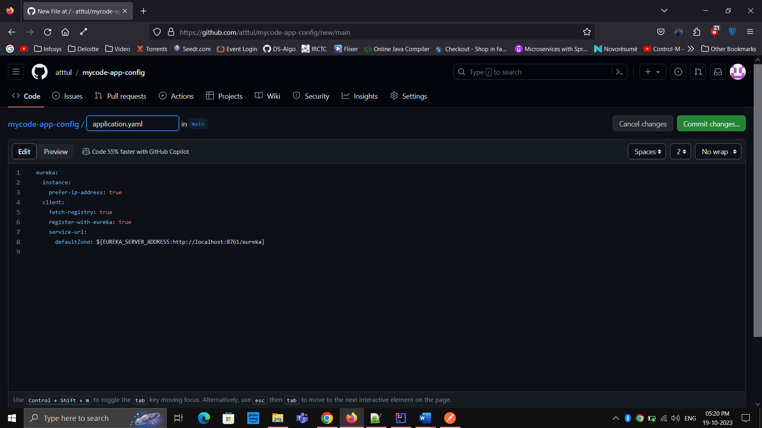

1. Now Add dependency Config Client to PRODUCT, ORDER, PAYMENT Services

<dependency>

<groupId>org.springframework.cloud</groupId>

<artifactId>spring-cloud-starter-config</artifactId>

</dependency>

8. Open application.yaml files of ORDER, PRODUCT, PAYMENT services and add this:

Spring:  
 config:  
 import: configserver:http://localhost:9296

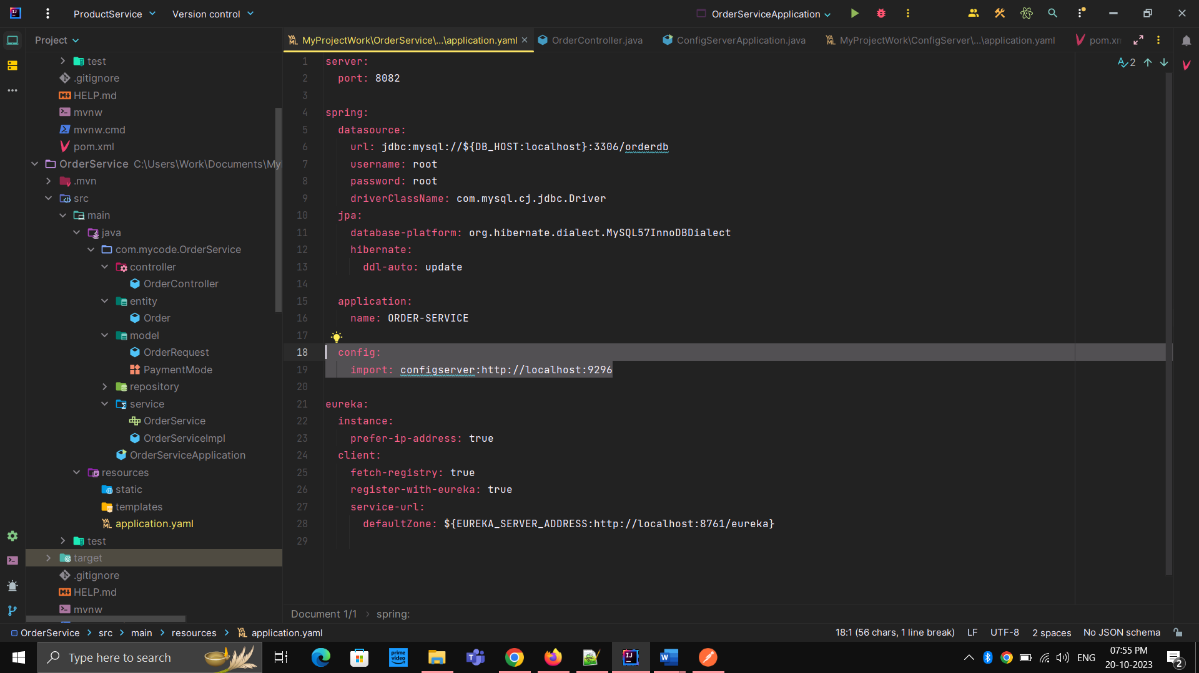9. Now first start config server then rest of the services